
TRIBHUVAN UNIVERSITY
Institute of Science and Technology

A Project Proposal
On
" Job Recommendation System"

Submitted to
Department of Statistics and Computer Science
Patan Multiple Campus

In partial fulfillement of the requriments for Bachelor Degree in Computer Science and Information Technology

Submitted By:
Swastika Dangol , 79010132
Ankita Gautam , 79012304
Rojina Shrestha , 79010091

Table of Contents
1. Introduction 1
2. Problem Statement 2
3. Objectives 2
4. Methodology 2
4.1. Requirement Identification 2
4.1.1 Study of Existing System 2
4.1.2 Requirement Analysis 3
4.1.2.1 Functional Requirement 3
4.1.2.2 Non-Functional Requirement 5
4.2. Feasibility Study 5
4.2.1 Technical Feasibility 5
4.2.2 Economic Feasibility 6
4.2.3 Operational Feasibility 6
4.2.4 Time Feasibility 6
4.3. High Level Design 6
4.3.1 Methodology of the Proposed System 6
4.3.2 System Flowchart 7
4.3.2 Description of Algorithm 10
5. Schedule 11
6. Expected Outcome 11
6. Reference 12

List of Figures
Figure 1: Use Case Diagram .................................................................................................. 4
Figure 2: Flowchart for Users ................................................................................................ 7
Figure 3: Flowchart for Employers ........................................................................................ 8
Figure 4: Flowchart for Admin .............................................................................................. 9

List of Tables
Table 1 : Gantt Chart for Job Recommendation System ....................................................... 11

Chapter 1

Introduction

Introduction
As the number of online job portals is increasing rapidly, it is becoming challenging for students as well as job seekers to find appropriate internships and jobs according to their skills and interests. The existing systems mostly provide general search results, but they do not recommend jobs in a personalized manner. This results in a time-consuming process for the users, especially fresh graduates and student who want to search for the most suitable internships.
A Job Recommendation System is a web-based application that recommends suitable internships and jobs to the users based on their individual profiles. The system compares the users information, such as skills, education and interests, with the job requirements provided by the companies and recommends the suitable and appropriate internships and jobs to the users.
Users can add their skills, education, experience in their profile information, based on which the system recommend the jobs and internship to them that match their profile. Whereas the job provider companys can post vacancies of internship or job on the system which clearly explain the required skills and qualifications for the position. The system comapres the requirement posted by company and the information of users, and suggests the suitable internships and jobs to the users.
The system will be developed using a web-based platform that can be accessed by users from anywhere. The system will have a user-friendly interface that enables students and job seekers to create their own profile and receive personlized recommendations.The system will use a content-based recommendation approach to match user profiles with job and internships description. The system will use basic technique like content-based to identify important skills and consine similarity to identify the best match. In additon, users will be able to filter results by type, location..
Therefore, this project aims to develop a smart and efficient recommendation system that makes the job and internship searching process easier, faster and more accurate.

Problem Statement
Before the introduction of online platforms for jobs and internships, the process of searching for jobs and intenships was difficult and time-consuming . Students and job seekers had to manually visit different offices or rely on notice boards and personal contacts to find the required and suitable jobs and internships. The process was confusing, stressful and inefficient, especially for fresh graduates and students who were not always aware of which positions matched their skills, education and career goals. many opportunities were missed simply due to lack of information or access. Similarly, the employer also faced difficulties in searching for the suitable candidates for the available positions. Overall, both students and employers struggled due to lack of a structed, organized and accessible platform, resulting in asted time, effort and missed opportunities for suitable matches.

Objectives
The main objectives of Job Recommendation System are:
- To develop a secure and user-friendly recruitment platform for job seekers, employers, and administrators.
- To implement a hybrid content-based recommendation approach using TF-IDF, Cosine Similarity, and weighted scoring to recommend suitable jobs based on candidate skills and job requirements
- To assist employer in efficiently identifying appropriate candidates, thereby reducing time and effort in the recruitment process.
- To integrate Google Gemini AI for automatically generating job descriptions, responsibilities, and required skills from a given job title, reducing employers' manual effort.

Scope and Limitations

Scope
The proposed Job Recommendation System is a web-based application designed to simplify the recruitment process for job seekers and employers. The system enables job seekers to create and manage their profiles, upload resumes, browse available jobs, receive personalized job recommendations, and apply for suitable positions. Employers can post job vacancies, manage applications, review candidate profiles, and evaluate match scores to support recruitment decisions.
The system also provides secure user authentication, role-based access control, and an intelligent recommendation engine based on Cosine Similarity to recommend jobs according to a candidate's skills. As a web application, the system can be accessed through any modern web browser with an internet connection.

Limitations
The proposed system has the following limitations:
- The recommendation results depend on the accuracy and completeness of the skills and profile information provided by job seekers.
- The recommendation algorithm primarily considers skill similarity and optional filters such as job type and work mode; it does not currently incorporate machine learning or behavioral analysis.
- The system is designed as a web application and requires an active internet connection for access.

Development Methodology
The Job Recommendation System was developed using the Waterfall Software Development Life Cycle (SDLC) model. The Waterfall model is a sequential software development approach in which each phase is completed before proceeding to the next phase. It provides a structured framework for software development and is suitable for projects with clearly defined requirements [9].
The development process of the proposed system consists of the following phases:
- Requirement Analysis
During this phase, the functional and non-functional requirements of the system were gathered by studying the existing recruitment process and identifying the needs of job seekers, employers, and administrators. The project requirements were analyzed to determine the system features, constraints, and objectives.
- System Design
During this phase, the functional and non-functional requirements of the system were gathered by studying the existing recruitment process and identifying the needs of job seekers, employers, and administrators. The project requirements were analyzed to determine the system features, constraints, and objectives.
- Implementation
The designed system was implemented using React.js for the frontend, ASP.NET Core Web API for the backend, Entity Framework Core for database interaction, and SQL Server for data storage. The recommendation module was implemented using the Cosine Similarity algorithm to calculate candidate-job match scores.
- Testing
The completed system was tested using unit testing, integration testing, and system testing to verify that all modules function correctly and satisfy the specified requirements.
- Deployment and Maintenance
After successful testing, the application was deployed for use. Continuous maintenance is performed to fix bugs, improve performance, and introduce new features based on user feedback and changing recruitment requirements.

Report Organization
This report has been prepared following the guidelines prescribed by Tribhuvan University. It is organized into preliminary pages and six main chapters. The preliminary pages include the Cover Page, Title Page, Recommendation, Approval Sheet, Certificate, Acknowledgement, Abstract, Table of Contents, List of Figures, List of Tables, and List of Abbreviations.
The main report is divided into the following six chapters:
Chapter 1: Introduction
This chapter introduces the Smart Job Recommendation System and provides an overview of the project. It presents the background of the study, problem statement, objectives, scope and limitations, development methodology, and the organization of the report.
Chapter 2: Background Study and Literature Review
This chapter reviews the concepts and technologies related to online job portals, recommendation systems, and machine learning techniques used in job recommendations. It also analyzes existing job portal systems, identifies their limitations, and highlights the need for the proposed system.
Chapter 3 : System Analysis and Design
This chapter presents the functional and non-functional requirements of the system, feasibility analysis, use case analysis, and system architecture. It also includes UML diagrams, Data Flow Diagrams (DFDs), Entity Relationship (ER) Diagram, database design, and user interface design.
Chapter 4: System Implementation
This chapter describes the implementation of the Smart Job Recommendation System using ASP.NET Core Web API, React.js, SQL Server, and Entity Framework Core. It explains the implementation of different system modules, recommendation logic based on skill matching, authentication and authorization, and key code snippets.
Chapter 5: Testing
This chapter presents the testing process carried out to verify the correctness and functionality of the system. It includes unit testing, integration testing, functional testing, test cases, system screenshots, recommendation results, and discussion of the overall system performance.
Chapter 6 : Conclusion and Future Recommendations
This chapter summarizes the overall project, discusses the achievements and limitations of the developed system, and provides recommendations for future enhancements, such as incorporating advanced machine learning algorithms, personalized recommendation techniques, resume parsing, and interview preparation features

4. Methodology

4.1. Requirement Identification
Requirement Identification is the process of gathering all the necessary information and requirements that will be used to design and develop a system. It is about figuring out what the system should do, that feature it needs and what resources are required to make it work.

4.1.1 Study of Existing System
Most existing job and internship portals are just displaying a list of jobs according to some keywords or basic filters. They don't consider a person's skills, education, experience and interests , so the results are often not very useful[1]. Student and new graduates have to go to many portals, offices or notice boards to find the right oppoortunity, which is a time consuming, exhausting and confusing process . Similarly, the employers also have problems finding the right candidates beacuse there is no mechanism to match the people with the job they are most suitable for. Recent research indicates that even simple recommendation methods, such as comparing skills and requirements can improve the speed and accuracy of job matching indicating the need for a smarter system [2].

4.1.2 Requirement Analysis
Requirement Analysis is the study of what the system should do and how it should behave. This is one of the significant steps in software development because it enables developers and other skateholders to agree on the system's requirements before it is developed. Job Recommendation System helps students and job seekers find the suitable internships and jobs based on their skills, education and experiences.

4.1.2.1 Functional Requirement
Job Seeker
- Job Seeker can easily register accounts and login to their accounts.
- Job Seeker can add and update their skills, education and work experience.
- Job Seeker can search and filter available jobs and internships.
- Job Seeker can apply for suitable jobs and internships.
- Job Seeker will receive job recommendations based on their profile.
Employer
- Employer can register and login to the system.
- Employer can enter job and internships details.
- Employer can post job and internship vacancies.
- Employer can view applicants for their posted jobs and internships.
- Employer can update or remove job postings when required.
Admin
- Admin can login the system.
- Admin can approve or reject job and internships postings.
- Admin can manage user acccounts.
- Admin can monitor and manage overall system activities.
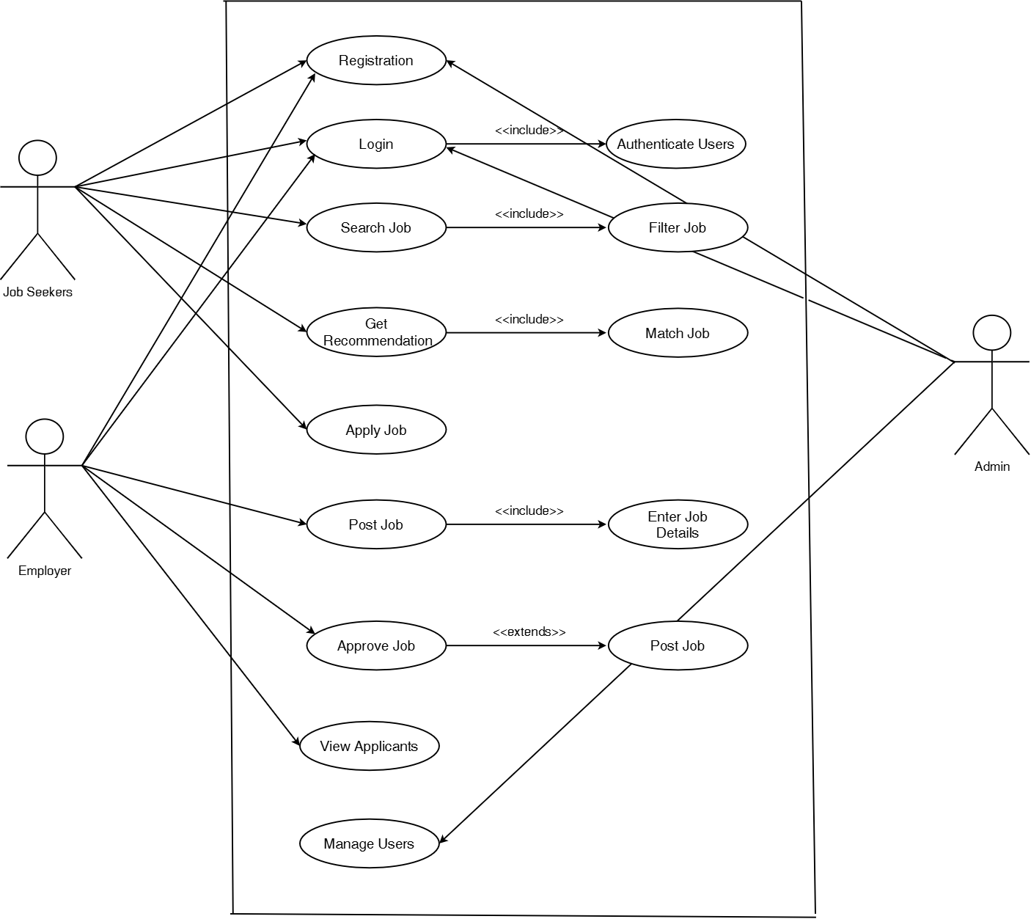

Figure 1: Use Case Diagram

4.1.2.2 Non-Functional Requirement
Availability
The system will be available for use by the users at any given time and from any geographical location through the use of a web browser and internet. This will ensure that the system is convenient for the users, as they will be able to log in and view the recommendations for jobs or interships without any restrictions or effort.
Reliability
The system will ensure that the users are provided with consistent and accurate recommendations based on their profiles.
User Interaction
The users will be able to interact with the system, as it will have a clear, attractive and user- friendly interface. This will ensure that the students are able to navigate through the registration process, creating profiles as well as the recommendations in a smooth manner.

4.2. Feasibility Study
A feasibility study helps us understand whether the proposed system can be developed and is useful in real life. It test various factors such as technology, cost and usability before beginning the development process

4.2.1 Technical Feasibility
This system can be developed by using common and easily available technilogies such as a web interface, database and simple machine learning techniques. It does not require any special or costly hardware. Since these tools are already in use and available, this system can be developed. From the usage point of view, the system will be easily accessible and usable via a web browser. Users such as job seekers and employers will be able to register, login and carryout their tasks without the need for any advances technical knowledge. The system will provide a user-friendly interface for searching, posting and managing jobs.

4.2.2 Economic Feasibility
This system can be developed at a low cost as most of the tools and softare used are free and open-source. No costly hardware is required. It also saves time and effort for users searching for jobs or internship, making it a cost-effective system.

4.2.3 Operational Feasibility
The system will be user-friendly for students, job seekers and employers. User will require only basic computer or mobile operating skills to use this system. It will enable students to quickly find appropriate jobs and internships and employers can also easily post job opportunities. Thus, the system can be easily operated in real life.

4.2.4 Time Feasibility
The system can be completed within the given time frame for the project. The project will be developed in stages: first understanding the requirements and designing the system then building it, testing it and finally documenting everything.

4.3. High Level Design

4.3.1 Methodology of the Proposed System
The proposed Recommendation System will be implemented using the Waterfall Methodology. In this methodology, the development of a system is done step by step. First of all, system requirements like information about user, jobs, internship details, and recommendation algorithms. Then the system design will be prepared after gathering the requirements. After this step, system development will begin where each module will be implemented. Once the development completed, the system will be tested throughly to ensure all features work correctly. Finally, the system will be implemented and users can make use of it to get internship and jobs[3].

4.3.2 System Flowchart

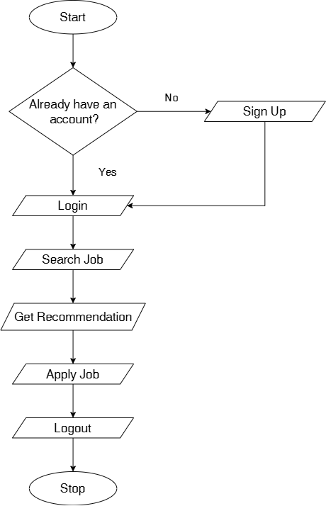

Figure 2: Flowchart for Users

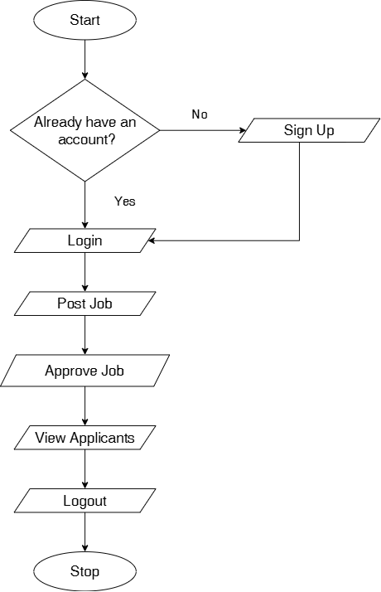

Figure 3: Flowchart for Employers

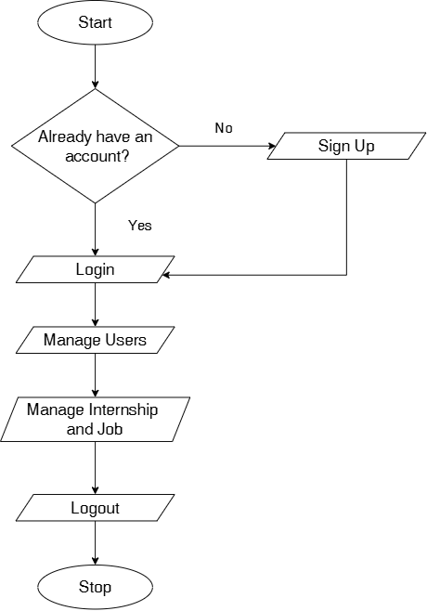

Figure 4: Flowchart for Admin

4.3.2 Description of Algorithm
This system uses a content-based algorithm to provide the best job recommendations to the user. This algorithm works by considering the user's profile such as skills, education, experience, and interests and comparing it with the job requirements. Each job is given a match score depending on the number of user skills that match the job requirements.
The match is calculated using the following formula:
U . J
Similarity (cosθ) =
||U|| × ||J||
Once the match scores are determined, the system lists the jobs from highest to lowest, ensuring that the most appropriate job are ranked at the top of the recommendation list using ranking algorithm.. To make the recommendations more relevant to the user, the system use rule-based filtering which means that the system filters the jobs based on certain criteria such as part time or full time job[4,5].
Working Algorithm:
- Read user profile which includes skills, education and experience.
- Fetch all the jobs and internship from database.
- For each job in job list:
  - Compare user skills with job required skills.
  - Calculate number of matching skills. iii. Calculate match score using the formula:
U . J
Similarity (cosθ) =
||U|| × ||J||
- Store each job and match score in list
- Sort job list in descending order according to the match score.
- Apply rule based filters:
  - JobType matches user preference (Full-Time/ Part-Time)
  - WorkMode matches user preference (Remote/On-Site)
  - PositionType matches user preference ( Job/Internships)
- Show final sorted and filtered job list to user.

5. Schedule
The project will be completed in a planned and organized way within the given time period. The project will include different phases such as requirement analysis, design, development, testing and documentation, which would be done on time as per the time chart provided below.
Table 1 : Gantt Chart for Job Recommendation System
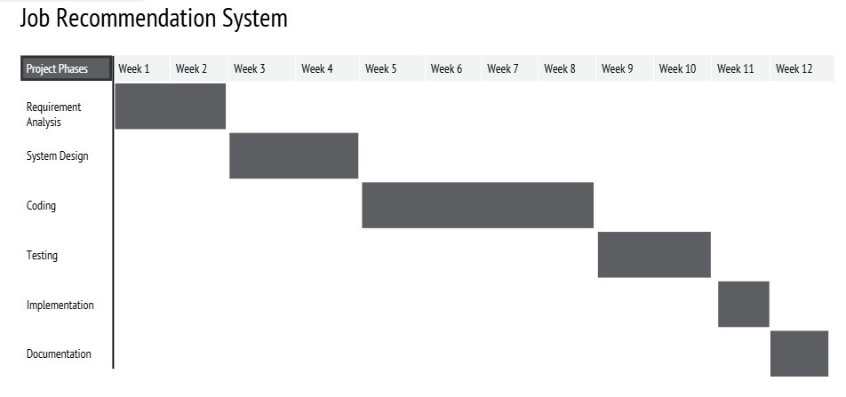

6. Expected Outcome
The Job Recommendation System is expected to help users easily find internships and jobs that suit their skills and education. The system will be able to save the user's time and enable user to search for job in a quicker and efficient manner. The system will have a simple and user-friendly interface for the users to create a profile and view recommendations .

6. Reference
- J. R. A. Kumar, B. Gupta, N. Kumar, D. Choudhary, and L. Jain, “Job and Internship Recommendation System,” Journal of Science, Computing and Engineering Research, vol. 8, no. 05, 2025.
- S. Soni and S. Shah, “Job Recommendation Systems Through AI and Machine Learning,” International Journal of Basic and Applied Sciences, 2025.
- D. Roy and M. Dutta, “A systematic review and research perspective on recommender systems,” Journal of Big Data, vol. 9, art. 59, 2022. Open access.
[Online].
Available: https://journalofbigdata.springeropen.com/articles/10.1186/s40537-022-
00592-5
- F. Ricci, L. Rokach, and B. Shapira, Recommender Systems Handbook, 2nd ed. Springer, 2015.
- M. J. Pazzani and D. Billsus, "Content-based recommendation systems," in The Adaptive Web, P. Brusilovsky, A. Kobsa, and W. Nejdl, Eds. Springer, 2007, pp.
325–341.

